



INTERNSHIP REPORT

By:
Bridgit Kangai & Hilda Kemboi
  - Equity Afia Section 58, Nakuru
  - Duration: 2nd September – 11th October 2025
  - Submitted in Partial Fulfillment of the Requirements for the Data Science Internship Program

Abstract
This report summarizes a six-week data science internship at Equity Afia Section 58, Nakuru. The project's primary goal was to apply data science techniques to address a genuine healthcare challenge within the facility. Our initial proposal involved developing a triage optimization system. However, upon arrival, we observed that the patient volume was lower than anticipated, making a triage system less critical. Through direct engagement with clinicians, nurses, and administrative staff, we identified a more pressing problem, a significant number of patients were failing to attend their scheduled follow-up appointments after being discharged. This issue compromised the continuity of care and patient health outcomes. To address this gap, we pivoted our project to focus on designing, building, and deploying a machine learning-based prediction model. This model identifies patients at high risk of missing their follow-ups. Additionally, we developed an interactive, user-friendly dashboard that empowers healthcare workers to monitor, prioritize, and engage with at-risk patients, thereby improving follow-up rates and strengthening the facility's decision-making capabilities.

1.0 Introduction
This internship at Equity Afia Section 58 provided a valuable opportunity to bridge the gap between theoretical data science and its practical application in a community healthcare setting. We began with a plan to create a predictive model for patient triage, aiming to streamline the process of prioritizing patients based on the severity of their condition. However, our initial assessment of the facility revealed a key constraint: the daily patient inflow was not high enough to justify or benefit significantly from an triage system. This prompted us to identifying another gap.
We conducted interviews and meetings with various staff members, including the clinical officer, the receptionist, and the data entry clerk. These discussions highlighted a major challenge: managing patient follow-ups. Staff reported that manually tracking which patients were due for a review was inefficient and often led to missed appointments. This problem of patient "defaulting" directly impacts the quality of care, particularly for patients with chronic conditions like diabetes and hypertension, which are common at the facility. Recognizing this, we refocused our project entirely on solving the follow-up management problem, leveraging data to provide a practical solution for the clinic.

2.0 Background of the Problem
Continuity of care is important for effective healthcare. For many conditions, especially chronic diseases, successful treatment depends not only on the initial consultation but also on consistent monitoring through follow-up visits. These appointments allow clinicians to assess a patient's progress, adjust medications, and catch potential complications early.
Despite its importance, ensuring patients return for follow-ups is a common struggle for healthcare facilities worldwide. Patients may forget, face financial constraints, or struggle to take time off work. At Equity Afia Section 58, the process for tracking these appointments was entirely manual. The staff relied on spreadsheets and paper registers to record follow-up dates. This method is inherently prone to human error, is time-consuming, and makes it difficult to get a quick overview of which patients need attention. As a result, reminders were often missed, and patients who failed to attend were not consistently followed up. This project was initiated to replace this manual, reactive process with an automated, data-driven, and proactive system.

2.1 Problem Statement
Equity Afia Section 58 lacked an efficient, automated system for monitoring discharged patients and predicting which individuals were most likely to miss their scheduled follow-up appointments. The reliance on manual tracking using spreadsheets resulted in operational inefficiencies, missed patient reviews, inconsistent data quality, and delayed clinical interventions. Consequently, there was a critical need to develop a predictive tool that could automatically identify high-risk patients early, enabling the healthcare team to take proactive measures to improve follow-up compliance and enhance patient care outcomes.

2.2 Objectives
The main objective of this project was to develop a functional machine learning model to predict a patient's risk of defaulting on their follow-up appointment.
To achieve this main goal, we set the following specific objectives:
- To gather, clean, and preprocess historical patient discharge and follow-up data from Equity Afia Section 58.
- To perform exploratory data analysis to identify the key factors and patterns associated with patients missing their follow-ups.
- To train, evaluate, and select the most suitable machine learning model for classifying follow-up default risk.
- To design, build, and deploy an interactive web-based dashboard that allows clinic staff to use the model and visualize patient data easily.

2.3 Justification of the Study
Missed follow-up appointments represent a breakdown in the care process. For the patient, it can lead to worsening health, disease complications, and higher treatment costs in the long run. For the clinic, it leads to poor health outcomes for their community, inefficient use of resources, and gaps in medical records.
This study is justified because it moves the clinic from a reactive to a proactive state. Instead of wondering why a patient did not show up, the staff can now use data to predict who might not show up and intervene beforehand. This proactive approach strengthens the clinic's ability to manage chronic diseases effectively, improves operational efficiency, and demonstrates a practical application of data science for improving community health.

2.4 Scope of the Study
The scope of this project was carefully defined to ensure it was achievable within the internship period. The study used data exclusively from Equity Afia Section 58, focusing on records from September to October 2025. The analysis was limited to the variables available in the clinic's existing records, such as patient demographics, diagnosis, insurance status, and follow-up intervals. The project covered the full lifecycle of a data science project, including data extraction, cleaning, model development, and dashboard deployment. It did not, however, include integrating the system with other branches or implementing an automated SMS reminder service, though these are valuable recommendations in the future.

3.0 Methodology
We adopted a structured, approach commonly used in data science projects to ensure a reliable outcome.
3.1 Data Source
All data was sourced directly from Equity Afia Section 58's internal records. The primary sources were Microsoft Excel spreadsheets maintained by the data clerk and supplementary information from patient registers at the reception. The dataset included variables such as:
- Patient Demographics: Age, Sex, Occupation.
- Clinical Information: Primary Diagnosis (Condition Type), Number of Medications Prescribed.
- Administrative & Socio-economic Data: Insurance Status, Reason for Follow-up, and the number of days until the next appointment (Follow-up Gap).
3.2 Data Analysis Techniques
The data was processed and analyzed using Python, a powerful programming language for data science. Key libraries included:
- Pandas and NumPy: For data cleaning, transformation, and handling missing values.
- Matplotlib and Seaborn: For creating visualizations and conducting Exploratory Data Analysis (EDA). This helped us understand the relationships between different variables and follow-up outcomes, revealing initial patterns and trends.
3.3 Design of the Model
We framed this as a supervised learning problem, specifically a binary classification task. The goal was to predict a target variable we called "Follow-up Default Risk" (whether a patient would default or not).
- Input Features: The model used several independent variables to make its prediction, including Age, Condition Type, Sex, Occupation, Insurance Status, Number of Medications, and Follow-up Gap.
- Model Training and Selection: We trained and compared three different algorithms:
  - Logistic Regression: A simple and interpretable baseline model.
  - Random Forest: A more complex model that often provides high accuracy.
  - Gradient Boosting: A powerful model known for its performance on tabular data.
Model Comparison Results:
- Logistic Regression: Accuracy: 60.0%, ROC AUC: 0.659
- Random Forest: Accuracy: 63.3%, ROC AUC: 0.657
- Gradient Boosting: Accuracy: 60.8%, ROC AUC: 0.695
While Random Forest had a slightly higher accuracy, we selected the Gradient Boosting model for final deployment because it achieved the highest ROC AUC score. This metric is crucial for our purpose, as it measures how well the model can distinguish between the two classes (default vs. non-default). A higher AUC means it is better at correctly identifying the patients who are truly at risk, which is the core objective of our project.
LogisticRegression - Accuracy: 0.600, ROC AUC: 0.659
precision recall f1-score support

0 0.68 0.54 0.60 67
1 0.54 0.68 0.60 53

accuracy 0.60 120
macro avg 0.61 0.61 0.60 120
weighted avg 0.62 0.60 0.60 120

RandomForest - Accuracy: 0.633, ROC AUC: 0.657
precision recall f1-score support

0 0.64 0.78 0.70 67
1 0.62 0.45 0.52 53

accuracy 0.63 120
macro avg 0.63 0.61 0.61 120
weighted avg 0.63 0.63 0.62 120

GradientBoosting - Accuracy: 0.608, ROC AUC: 0.695
precision recall f1-score support

0 0.64 0.67 0.66 67
1 0.56 0.53 0.54 53

accuracy 0.61 120
macro avg 0.60 0.60 0.60 120
weighted avg 0.61 0.61 0.61 120

3.4 Model Deployment Interface Design
To make the model useful for daily clinic operations, we built an interactive web application using Streamlit. This dashboard provides a simple interface where a staff member can input or select a patient's details. Upon clicking a button, the system instantly provides a prediction, classifying the patient's risk as Low, Medium, or High. The dashboard also includes several visualizations (charts and graphs) that give an overview of all patients, their follow-up statuses, and common diagnoses, replacing the static and cumbersome spreadsheet view.

4.0 Results
4.1 Analysis Results
The dashboard visualizations provided immediate, actionable insights for the clinic staff:

- Follow-up Status Overview: The pie chart showing the count of patients in each category (e.g., Overdue, Due Today, Due Tomorrow) gave a clear picture of the daily and weekly workload, making it easy to prioritize phone calls.
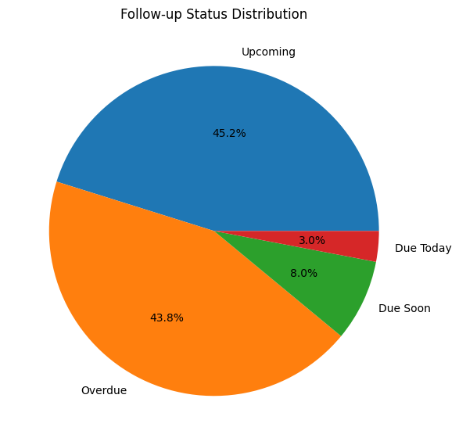

- Top Diagnoses: The bar chart confirmed that chronic conditions like Hypertension, Diabetes, and Urinary Tract Infections were the most common reasons for follow-ups. This visually reinforced the importance of the system for managing the clinic's core patient population.
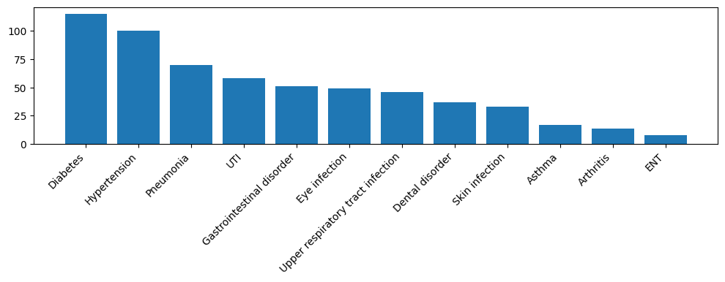

Follow-up Schedule Heatmap: The calendar heatmap illustrated how follow-up dates were distributed throughout the month. This allowed the clinic to anticipate busy periods and plan staff allocation accordingly.

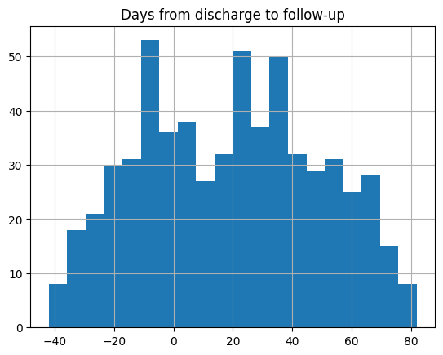

This chart presents the model’s risk classification for patients likely to default on follow-ups. It helped in identifying high-risk patients early, particularly those with no insurance coverage, long follow-up gaps, or complex medication count.

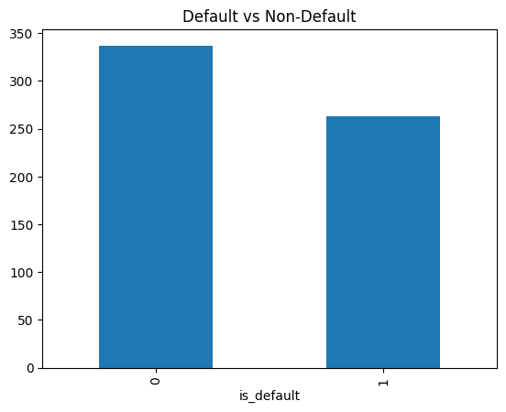

4.2 Model Results
The deployed Gradient Boosting model integrated seamlessly into the dashboard. It successfully generates a risk category for each patient, providing a data-driven basis for decision-making. The model's output helps answer the critical question: "Which patients should we call first today?"

5.0 Discussion
The findings from our model and the implementation of the dashboard directly adresses the problem statement.The problem was inefficient manual tracking leading to missed appointments and delayed interventions. Our solution directly addresses this in several ways.
First, the model identified key factors that make a patient likely to default, such as being employed but uninsured, or having a long gap until the next appointment. For example, when the model flags a patient without insurance as "High Risk," it tells the staff why that patient might be hesitant to return, perhaps due to cost. This allows for a more empathetic and effective intervention, such as discussing payment options.
Second, the dashboard completely transforms the follow-up tracking process. Before, a staff member had to manually scan through rows of a spreadsheet. Now, they open the dashboard and immediately see a visual summary. Patients who are "Overdue" or "High Risk" are displayed, eliminating the chance of them being overlooked. This saves time and reduces the mental load on the staff.
In essence, the project has shifted the clinic's approach from being reactive (noting who didn't come) to being proactive (predicting who might not come and preventing it). This directly resolves the issues of poor data accuracy and delayed interventions.

6.0 Conclusion and Recommendation
In conclusion, this internship project successfully delivered a practical and valuable data science solution to a real-world problem at Equity Afia . The follow-up prediction model and interactive dashboard have provided the facility with a powerful tool to improve patient monitoring, enhance operational efficiency and patient outcomes.
To ensure the long-term success and expansion of this system, we recommend the following:
- Continuous Model Retraining: The model's performance is based on current data patterns. The clinic should periodically (e.g., every 6 months) retrain the model with new patient data. This will ensure the predictions remain accurate as patient demographics and behaviors change over time.
- Pilot Expansion to Other Branches: The core system developed for Section 58 has the potential to benefit other Equity Afia clinics. We recommend a pilot program to deploy this tool in one or two other branches, adapting it to their specific data and needs.
- Integration with Communication Tools such as sms: To maximize impact, the logical next step is to connect the dashboard to an automated communication channel. We recommend integration with an SMS,or calls. This would allow the system to automatically send reminder messages to patients categorized as "Medium" or "High" risk, further reducing the manual workload for staff.

7.0 References
- Equity Afia Data Department (2025). Facility Discharge and Follow-up Records.
- Scikit-learn Documentation. (2024). Machine Learning in Python. https://scikit-learn.org/
- Streamlit Documentation. (2024). Streamlit for Data Applications. https://streamlit.io/

Appendices
